

HUMAN BIOLOGICAL SCIENCE SAMPLE EXAMINATION

Section 7 of the New WACE Manual: General Information 2006–2009 outlines the policy on WACE examinations.

Further information about the WACE Examinations policy can be accessed from the Curriculum Council website at http://newwace.curriculum.wa.edu.au/pages/about_wace_manual.asp.

The purpose for providing a sample examination is to provide teachers with an example of how the course will be examined. Further finetuning will be made to this sample in 2007 by the examination panel following consultation with teachers, measurement specialists and advice from the Assessment, Review and Moderation (ARM) panel.
0000.doc




WACE Examination 2007

Question/Answer Booklet

HUMAN
BIOLOGICAL
Please place your student identification label in this box
SCIENCE
Units 2A/2B

Student Number: In figures

In words

Time allowed for this paper
Reading time before commencing work: Ten minutes
Working time for paper: Three hours

Material required/recommended for this paper

To be provided by the supervisor
Question Answer Booklet
Standard Answer Booklet

To be provided by the candidate
Standard items: Pens, pencils, eraser or correction fluid, highlighter, ruler, printed English language dictionary and/or bilingual dictionary (non electronic and not a thesaurus)
Special items: Calculators satisfying the conditions set by the Curriculum Council for this course.

Important note to candidates
No other items may be taken into the examination room. It is your responsibility to ensure that you do not have any unauthorised notes or other items of a non-personal nature in the examination room. If you have any unauthorised material with you, hand it to the supervisor before reading any further.

Structure of this paper

Section | Outcomes | Suggested working time | Number of questions available | Number of questions to be attempted
ONE  Short response | 1, 2, 3 | 60 min | 5 | 5
TWO  Short response | 2, 3 | 60 min | 4 | 4
THREE  Extended response | 2, 3 | 60 min | 4 | 2

Mark allocation is yet to be done.
Instructions to candidates

- The rules for the conduct of Curriculum Council examinations are detailed in the Student Information Handbook. Sitting this examination implies that you agree to abide by these rules.

- Answer the questions in the Answer Booklet provided according to the following instructions:

Section 1: All students are to attempt this section.
Answer all questions in Section 1. Read every question carefully before you answer. A blue or black ball point or ink pen should be used. Your writing or printing must be LEGIBLE. Answer in the spaces provided on the paper

Section 2: Answer all questions presented. Answer all parts of your chosen three questions. Answer in the spaces provided on in the question answer booklet.

Section 3: Answer two (2) questions from the four (4) questions presented. Answer in of the standard answer booklet provided.

The purpose of this examination is to provide each candidate with the opportunity to demonstrate his/her level of achievement of the Human Biological Science course outcomes. Some questions may provide candidates with the opportunity to demonstrate achievement at a restricted range of levels. Other questions may provide the opportunity to demonstrate achievement over the full range of levels.

Section 1

Answer ALL questions in Section 1. Answer in the spaces provided on the paper.

Question 1

A scientist was investigating the effectiveness of a newly developed drug, Neurogen and its ability to improve recovery from nerve cell injury. The experiment was performed as described.

Nerve cells were placed into culture medium (a solution containing nutrients to keep the cells alive and help them grow). An equal number of nerve cells (in culture medium) were transferred into thirty test tubes and maintained under constant temperature and oxygen levels. Ten of the test tubes received no treatment, ten tubes received a large, single dose of Neurogen and the remaining ten tubes had a series of smaller doses of Neurogen added each week until week 8. The total amount used in the series of small doses was the same as the single large dose. The treatment started week 2 of the investigation.

At the end of each week one test tube was selected from each treatment and the growth of nerve axons in the test tubes was measured. The results are shown in the table below.

Table 1: Growth of nerve axons with different treatments of Neurogen.

Time  (weeks) | Treatment  A  No treatment | Treatment  B  Single large dose | Treatment  C  Series of small doses
0 | 0.01 | 0.02 | 0.01
1 | 0.04 | 0.06 | 0.05
2 | 0.05 | 0.07 | 0.08
3 | 0.10 | 0.15 | 0.21
4 | 0.12 | 0.30 | 0.35
5 | 0.15 | 0.45 | 0.50
6 | 0.16 | 0.55 | 0.65
7 | 0.18 | 0.56 | 0.80
8 | 0.19 | 0.58 | 1.00
9 | 0.20 | 0.58 | 1.15
10 | 0.21 | 0.59 | 1.20

(a) Draw an appropriate graph to represent the results in Table 1.

(b) State a possible conclusion from this experiment.
[x marks]

(c) Discuss two (2) possible sources of error in this experiment to make suggestions on how the reliability of the results could be improved.
[x marks]

(d) Explain why measurements were taken for two weeks before treatments were given.
[x marks]

(e) The last dose for treatment C was given at the beginning of week 8. What would be expected to happen to axon growth over the next few weeks? Explain the reasons for your answer. [x marks]

Question 2

A researcher working for a pharmaceutical company had developed an adrenalin related compound (‘Drug X’) which showed promise as a bronchodilator in the treatment of asthma. Bronchodilators are substances which cause the muscular walls of the airways to relax during an asthma attack thus making breathing easier. Side-effects of adrenalin-like substances are increased heart rate and blood pressure. The pharmaceutical company already has another asthma drug, Asthmat, on the market. The effectiveness of Asthmat is limited if not taken at the first signs of an asthma attack.

Using the above information design an investigation to compare the effectiveness of ‘Drug X’ and Asthmat. Ensure you consider the following:
- variables
- hypothesis
- pre-testing
- a methodology to allow ethical and safe data collection
- measures to achieve reliability and reduce errors.
[x marks]

Question 3

Cells continually exchange materials with their surroundings. The following table shows the concentrations on a range of materials in the extracellular and intracellular fluids of a human body cell.

Table 2: Concentrations of materials in extracellular and intracellular materials

Material | Extracellular fluid | Intracellular fluid
Sodium ions | 137 mEq/L | 10 mEq/L
Potassium ions | 5 mEq/L | 141 mEq/L
Calcium ions | 5 mEq/L | 0 mEq/L
Chloride ions | 108 mEq/L | 4 mEq/L
Glucose | 90 mgm% | 0-20 mgm%
Amino acids | 30 mgm% | about 200 mgm%
Oxygen | 35 mm Hg | 20 mm Hg
Carbon dioxide | 46 mm Hg | 50 mm Hg
Water | 92-98% | 92-98%

(a) Identify which materials would tend to diffuse into the cell and give reasons why.
[x marks]

Figure 1: Three types of movement of materials across a cell membrane
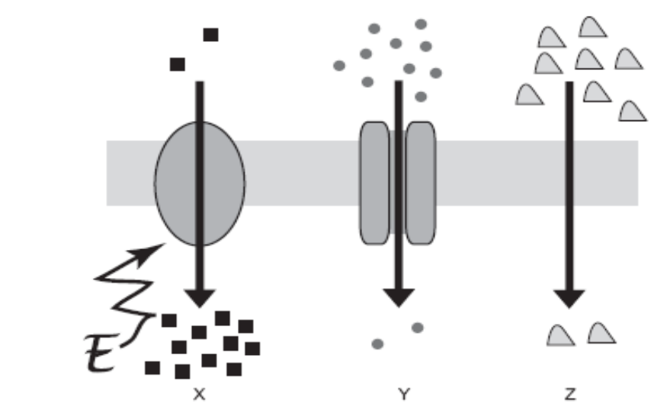
(Victorian Curriculum and Assessment Authority, 2006)

(b) Sodium, glucose and oxygen are exchanged between the cell and its environment in different ways.
Match the type of movement, shown in Figure 1: at X, Y and Z, to one of materials, sodium, glucose and oxygen.

X: ________________

Y: ________________

Z: _________________
[x marks]
Explain why different types of movement are used for each of the materials.

(c) What material would move into and out of the cell by osmosis? What factors would affect the rate and direction of osmosis occurring between the cell and its surroundings?
[x marks]

(d) When amino acids enter the cell they can be made into many different proteins with different uses. Outline two uses of proteins related to the functions of the cell membrane.
[x marks]

THIS PAGE HAS BEEN LEFT BLANK INTENTIONALLY
Question 4
(Tasmanian Qualifications Authority, 2004)

Figure 2: Model of DNA structure

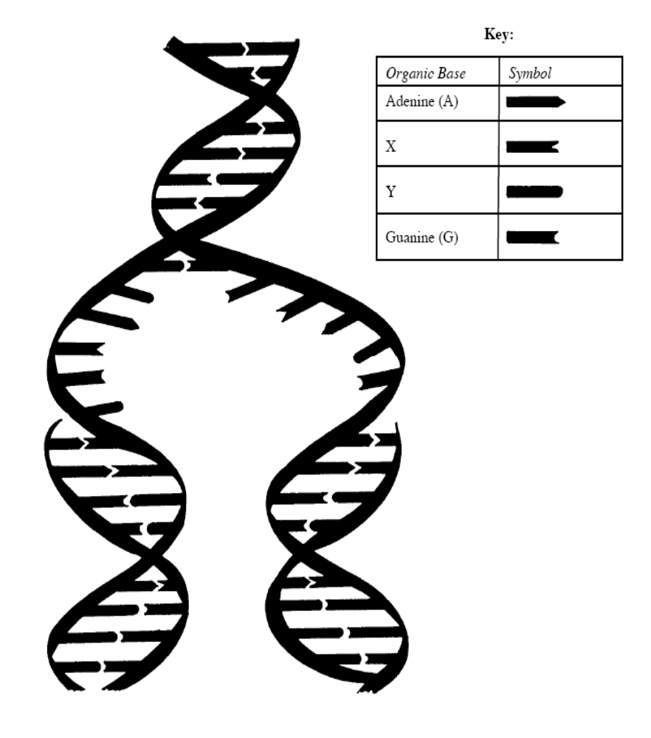

Use the information shown in Figure 2 to help answer the following questions.

(a) Identify the bases X and Y.
[x marks]
X : _______________ Y : __________________

(b) Name the process shown in the diagram. Explain why this process is important.
[x marks]

(c) Explain the importance of the sequence of bases along a DNA strand.
[x marks]

(d) Describe the consequences of a change in the base sequence if it occurs in a reproductive cell. [x marks]

(e) There were three suspects in an assault case. A forensic scientist found blood, other than the victim’s at the site. DNA was extracted from five blood samples:
- the victim.
- the blood at the assault site (not the victim’s)
- three suspects.

DNA profiles were made for each sample which indicate the alleles of a specific gene present in the DNA of each person.

Figure 3: Diagram of the DNA profiles produced form the blood samples.

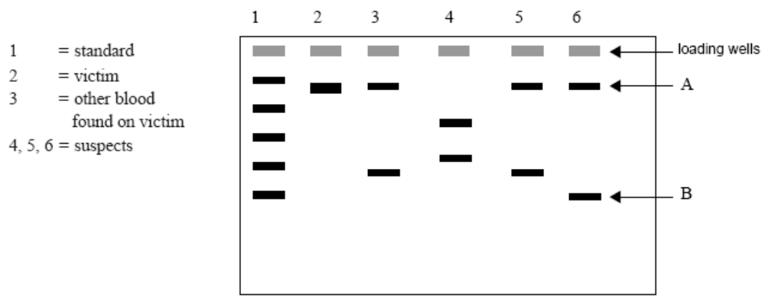
(Victorian Curriculum and Assessment Authority, 2002)

i. Which of the samples shown in Figure 3 indicates that the person is homozygous for the tested gene? Explain why.

ii. Which of the suspects appears to have committed the assault? Explain why you chose this suspect.
(Victorian Curriculum and Assessment Authority, 2002)

Question 5

Figure 4: Model of enzyme function

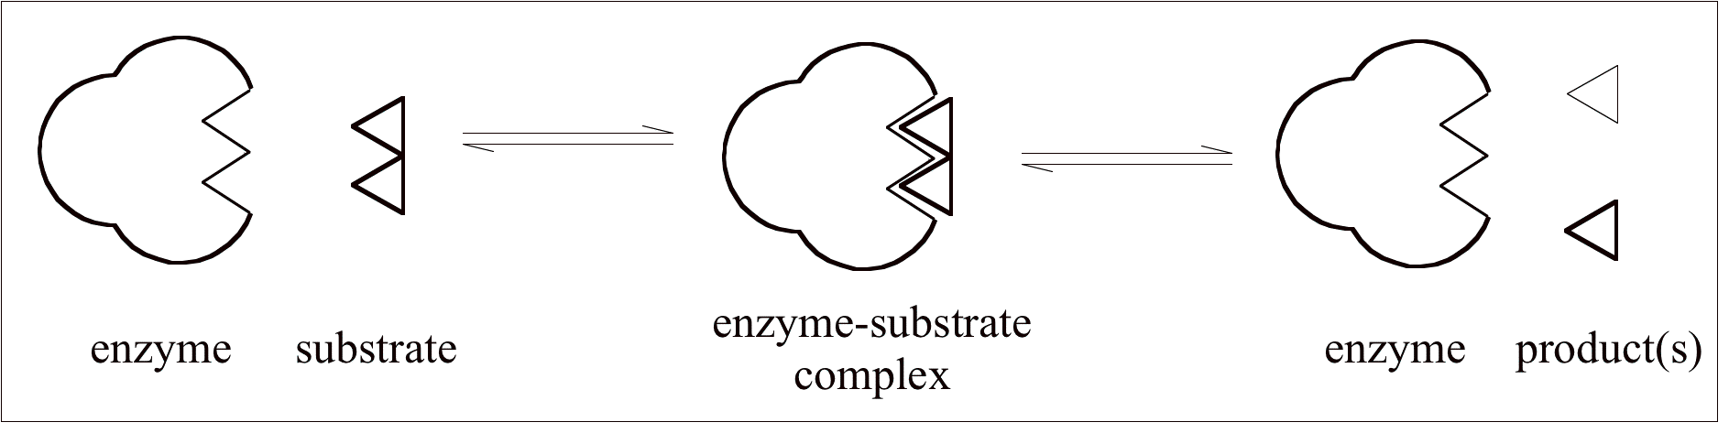
(Lecher, n.d.)

(a) Refer to Figure 4 to explain the effect of a change in an environmental factor on the operation of the enzyme. [x marks]

(b) Explain why enzymes are essential; for efficient functioning of cells [x marks]

(c) Phenylketonuria (PKU) is a genetic disorder in which an affected individual is unable to metabolise the amino acid phenylalanine. The defect is due to the lack of the enzyme phenylalanine hydroxylase. Part of the metabolic pathway involved is as follows in Figure 5.

Figure 5: Metabolic pathway of phenylalanine

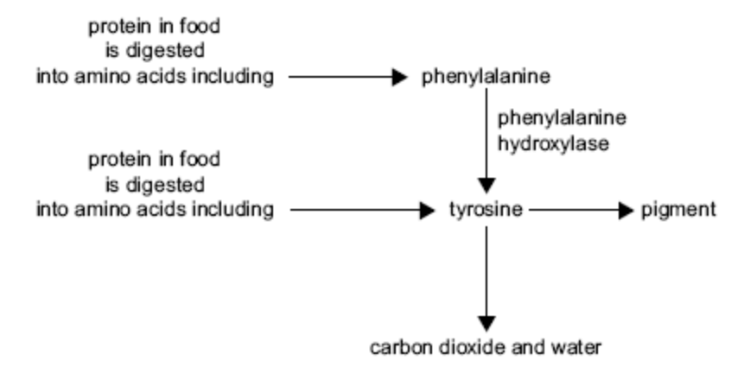

Before treatment of PKU was possible, it was observed that individuals with PKU often had lighter hair and skin than their non-affected siblings. With reference to the metabolic pathway above, explain this observation.

(Victorian Curriculum and Assessment Authority, 2004)

THIS PAGE HAS BEEN LEFT BLANK INTENTIONALLY
2A/2B Section 2: short answer section.

Answer ALL four (4) questions in this section. Answer in the spaces provided on the paper. Use blue or black ink to write your answers.

Question 1
The family tree in Figure 6 shows the incidence of cystic fibrosis in a family.

Figure 6: Cystic fibrosis inheritance

I
2
1

II
1
2
3
4
5

III

1
2
3
4
5
6
7
8
9
10

IV

1
2
3
4
5
6
7
8
10
11
12
13

?
V

1

(a) Describe the inheritance pattern of cystic fibrosis and justify your answer with evidence from the family tree. [x marks]

(b) State the possible genotypes of
[x marks]
I | 1
II | 2
III | 5
IV | 8

(c) What is the probability of IV 11 and IV 12 producing another daughter with cystic fibrosis? Show your reasoning. [x marks]

(d) Cystic fibrosis is one of many genetic conditions that can be diagnosed prenatally by performing genetic testing on the foetus by using chorionic villus sampling, as shown below.

Figure 7: Chorionic villus sampling
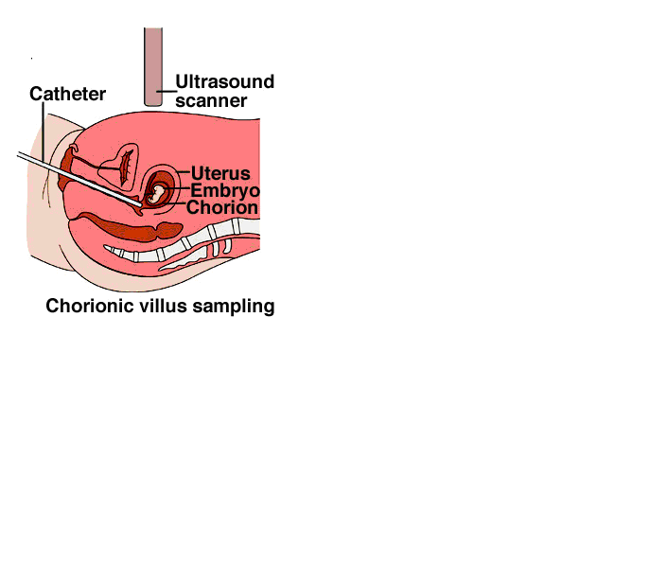
(Byer, Shainberg, & Galliano, 1999)

Explain how this test can determine the presence of cystic fibrosis in the embryo.
[x marks]

(e) Describe the risks associated with chorionic villus sampling.
[x marks]

Question 2

Figure 8: Structure of the respiratory system

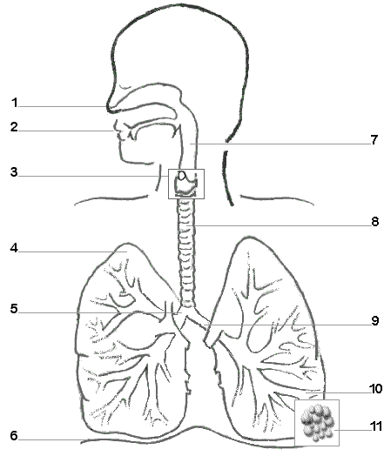
(Mikola, n.d.)

(a) Describe the main feature of the structures labelled 5, 8 and 9 and how it helps in the efficient movement of air into and out of the lungs.
[x marks]

(b) Explain how inspiration occurs. [x marks]

(c) People with cystic fibrosis produce excess mucus secretion in the airways of the lungs. This thickens the walls and reduces the volume of the alveoli. Explain how exchange of gases between the lungs and blood is affected by these changes.
[x marks]

(d) Explain how the symptoms in the respiratory system of people with cystic fibrosis effect a child’s ability to play active games.
[x marks]

(e) If someone has had a heart attack, the heart stops beating and breathing stops. CPR (cardiopulmonary resuscitation) can be carried out. CPR is a combination of artificial respiration and chest compressions.

Explain why both need to be done for the patient to survive.
[x marks]

Question 3

The body has defences that protect against invading micro-organisms.

(a) State how each of the following help to defend the body against disease.
[x marks]
tears.

stomach acid.

(b) While handling an old timber floorboard, Tom got a splinter in his wrist. He didn’t do anything about it until he had finished working an hour or so later. He tried to remove it, but some remained under the skin. The area around the splinter was red, warm and swollen compared to his other wrist. The next morning the remains of the splinter were surrounded by a sac of pus.

Figure 9: Diagrams showing the reaction to a splinter

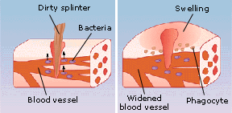
(Express Scripts, 2000)

Explain how each of these four changes helps the body fight infection. [x marks]

Question 4.

Figures 11 and 12 show a cell with a diploid number of 4 chromosomes undergoing two types of cell division. The processes of division are similar in each but there are very important differences.

Below are diagrams of each cell division type at metaphase. The chromosomes are lined up along the equator of the cell with the centromeres attached to the spindle fibres.

Figure 10: Cell division 1 Figure 11: Cell division 2

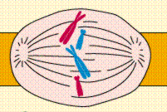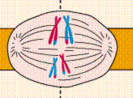
(Purves, c1995)

(a) State the type of cell divisions shown in the diagrams above.

Cell division 1:
Cell division 2:

Provide evidence from the diagram to support your answer.
[x marks]

(b) Compare the daughter cells of type 1 cell division with those of type 2 cell division.
[x marks]

Figure 12: Gamete formation in humans

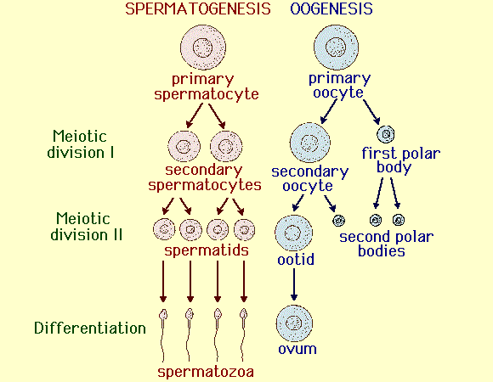
(Chynoweth, n.d)

(c) Account for the differences between the spermatozoa and the ovum.
[x marks]

Cells taken during amniocentesis testing were prepared and the karyotype for the foetus produced. The karyotype is shown in Figure 13.
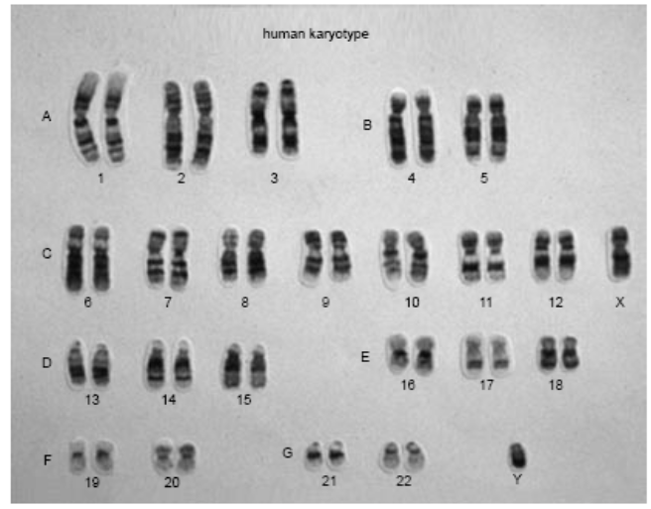
Figure 13: Karyotype of
Foetus

(Victorian Curriculum and Assessment Authority, 2003)

(d) What is the sex of the foetus? Use evidence in the photograph to support your answer.
[x marks]

(e) Karyotypes can be used to identify chromosomal mutations. Give an example of a chromosomal disorder and how it could be identified using a foetal karyotype.
[x marks]

(f) Why are chromosomal abnormalities more common in children born to older mothers?
[x marks]

2A/2B Section 3: extended answer section.

Answer TWO (2) questions from this section.
Answer EITHER question 1 or question 2.
Answer EITHER question 3 or question 4.
Answer on the lined paper provided at the end of the booklet.

Answer ONE question only from questions 1 and 2.

Question 1
(a) Briefly outline the pathway and processes by which carbohydrates are digested and absorbed into the blood.

(b) Lipids are an essential part of the diet. Outline the different uses of lipids in the body.

(c) Outline the impact of an active lifestyle on an adolescent’s nutrient intake and storage. [x marks]

OR

Question 2
Discuss the consequences of different lifestyle choices of an adolescent on his/her future health. [x marks]

Question 3

Figure 14: Foetal circulation.

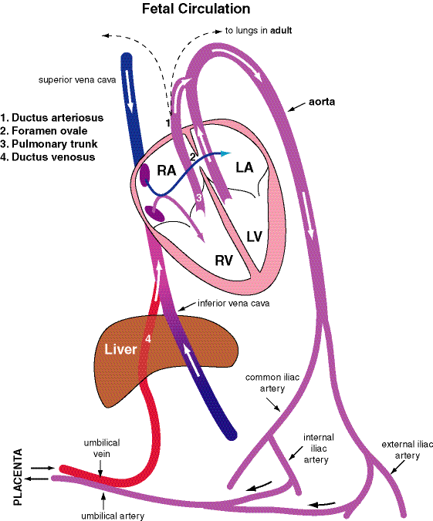
(Metropolitan State College of Denver, n.d.)

a. Explain the changes that occur in the circulation when a baby is born.
[x marks]

b. In some newborn babies, the blood vessel labelled 1 in Figure 14, which connects the pulmonary artery and the aorta, does not close up but remains open and causes the baby to appear pale blue in the face. Explain why. Explain the problems this would cause the growing child if left untreated.

OR

Question 4

Figures 15 and 16 below show the changes between weeks 4 and 8 of gestation

Figure 15: Week 4: How you looked at 1 month past conception

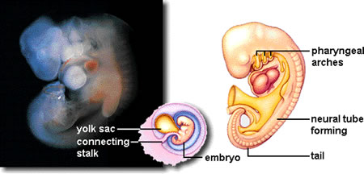(Marrs, 2004)

Figure 16: Week 8: How you looked when all of your major organ systems of the body are formed.

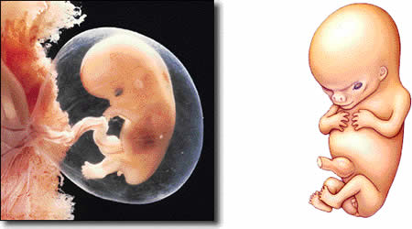(Marrs, 2004)

(a) Explain how different tissues, organs and systems can develop from the embryonic germ cell layers that are found in the embryonic disc.

(b) Most women do not know they are pregnant until they miss their second menstrual cycle at which time she could be about 6 weeks into her pregnancy. It is also during weeks 4-8 that most teratogens have an effect on the development of the embryo.

(i) Describe the precautions a woman can take to reduce the chances of her offspring being affected by teratogens.

(ii) Explain why teratogens cause the most damage at this stage of development. Use examples to support your answer.
[x marks]
END OF PAPER

ACKNOWLEDGEMENTS

SECTION 1

Question 3: Victorian Curriculum and Assessment Authority. (2006). Biology: Written examination 1 (p. 8, q. 24). Retrieved November, 2006, from www.vcaa.vic.edu.au/vce/studies/biology/pastexams/2006/2006biol1w.pdf.

Question 4a–c: Adapted from: Tasmanian Qualifications Authority. (2004). Tasmanian Certificate of Education: Biology: Senior Secondary 5C: external assessment (pp. 4–5, q. 5). Retrieved October, 2006, from http://www.tqa.tas.gov.au/4DCGI/_WWW_doc/007022/RND01/BIO5C_paper04.pdf.

Question 4e: Adapted, with the exception of 4e(i), from: Victorian Curriculum and Assessment Authority. (2002). Biology: Written examination 2 (pp. 18–19, q. 5). Retrieved November, 2006, from www.vcaa.vic.edu.au/vce/studies/biology/pastexams/biology22002.pdf.

Question 5: Lecher, C.S. (n.d.). Chapter 18 summary, Chapter 18 recommended homework problems. Retrieved October, 2006, from Marian College website: http://sonak.marian.edu/academ/departments/chem_phys/lecher/Ch18.htm.

Question 5c: Adapted from: Victorian Curriculum and Assessment Authority. (2004). Biology: Written examination 2 (p. 16, q. 3). Retrieved November, 2006, from www.vcaa.vic.edu.au/vce/studies/biology/pastexams/2004biol2.pdf.

SECTION 2

Question 1d: Byer, C.O., Shainberg, L.W., & Galliano, G. (1999). Dimensions of human sexuality (5th ed.). Dubuque, IA: McGraw-Hill. Diagram retrieved October, 2006, from McGraw-Hill website: http://www.mhhe.com/socscience/sex/common/ibank/ibank/0111.jpg.

Question 2: Mikola, J. (n.d.). Printable blackline diagram of the respiratory system. Retrieved October, 2006, from Lesson Tutor website: http://www.lessontutor.com/jm_respiratory.html.

Question 3b: Express Scripts. (2000). When bacteria enter the body and multiply, the body's first defense is inflammation. Retrieved October, 2006, from DrugDigest website: http://www.drugdigest.org/DD/HC/Causes/0,4045,6,00.html.

Question 4: Purves, W. (c1995). Life: The science of biology (4th ed.) (Diagrams: Metaphase I, The chromosomes line up on the equatorial (metaphase) plate; Metaphase, centromeres divide). Sunderland, MA: Sinauer Associates. Retrieved October, 2006, from Estrella Mountain Community College website: http://www.emc.maricopa.edu/faculty/farabee/biobk/BioBookmeiosis.html.

Question 4c: Chynoweth, D.P. (n.d). [Diagram of spermatogenesis and oogenesis]. Retrieved October, 2006, from University of Florida, Agricultural and Biological Engineering website: http://faculty.abe.ufl.edu/~chyn/age2062/lect/lect_08/12_29.GIF.

Question 4d: Victorian Curriculum and Assessment Authority. (2003). Biology: Written examination 2 (p. 2, fig. 1). Retrieved November, 2006, from http://www.vcaa.vic.edu.au/vce/studies/biology/pastexams/2003_biol2.pdf.

SECTION 3

Question 3: Metropolitan State College of Denver. (n.d.) Fetal circulation [Diagram]. Retrieved November 10, 2006, from http://www.mscd.edu/~biology/2320course/2320images/Fetal.gif.

Question 4: Marrs, K. (2004). Human reproduction and development: Class notes (Illustrations: Week 4: How you looked at 1 month past conception; Week 4–8 is when all the major organ systems of the body are formed and when most teratogens have their greatest effect). Retrieved October, 2006, from Department of Biology, Indiana University–Purdue University Indianapolis website: http://www.biology.iupui.edu/biocourses/n100/2k4ch39repronotes.html.
Published by the Curriculum Council of Western Australia
27 Walters Drive
OSBORNE PARK WA 6017

WACE Examination 2007

Question/Answer Booklet

HUMAN
BIOLOGICAL SCIENCE
Please place your student identification label in this box
Units 3A/3B

Student Number: In figures

In words

Time allowed for this paper
Reading time before commencing work: Ten minutes
Working time for paper: Three hours

Material required/recommended for this paper

To be provided by the supervisor
Question Answer Booklet
Standard Answer Booklet

To be provided by the candidate
Standard items: Pens, pencils, eraser or correction fluid, highlighter, ruler, printed English language dictionary and/or bilingual dictionary (non electronic and not a thesaurus)
Special items: Calculators satisfying the conditions set by the Curriculum Council for this course.

Important note to candidates
No other items may be taken into the examination room. It is your responsibility to ensure that you do not have any unauthorised notes or other items of a non-personal nature in the examination room. If you have any unauthorised material with you, hand it to the supervisor before reading any further.

Structure of this paper

Section | Outcomes | Suggested working time | Number of questions available | Number of questions to be attempted
ONE  Short response | 1, 2, 3 | 60 min | 5 | 4
TWO  Short response | 2, 3 | 60 min | 4 | 4
THREE  Extended response | 2, 3 | 60 min | 4 | 2

Mark allocation is yet to be done.
Instructions to candidates

- The rules for the conduct of Curriculum Council examinations are detailed in the Student Information Handbook. Sitting this examination implies that you agree to abide by these rules.

- Answer the questions in the Answer Booklet provided according to the following instructions:

Section 1: All students are to attempt this section.
Answer all questions in Section 1. Read every question carefully before you answer. A blue or black ball point or ink pen should be used. Your writing or printing must be LEGIBLE. Answer in the spaces provided on the paper

Section 2: Answer all questions presented. Answer all parts of your chosen three questions. Answer in the spaces provided on in the question answer booklet.

Section 3: Answer two (2) questions from the four (4) questions presented. Answer in of the standard answer booklet provided.

The purpose of this examination is to provide each candidate with the opportunity to demonstrate his/her level of achievement of the Human Biological Science course outcomes. Some questions may provide candidates with the opportunity to demonstrate achievement at a restricted range of levels. Other questions may provide the opportunity to demonstrate achievement over the full range of levels.

Section 1.

Answer ALL questions in Section 1. Answer in the spaces provided on the paper.

Question 1

A scientist was investigating the effectiveness of a newly developed drug, Neurogen and its ability to improve recovery from nerve cell injury. The experiment was performed as described.

Nerve cells were placed into culture medium (a solution containing nutrients to keep the cells alive and help them grow). An equal number of nerve cells (in culture medium) were transferred into thirty test tubes and maintained under constant temperature and oxygen levels. Ten of the test tubes received no treatment, ten tubes received a large, single dose of Neurogen and the remaining ten tubes had a series of smaller doses of Neurogen added each week until week 8. The total amount used in the series of small doses was the same as the single large dose. The treatment started week 2 of the investigation.

At the end of each week one test tube was selected from each treatment and the growth of nerve axons in the test tubes was measured. The results are shown in the table below.

Table 1: Growth of nerve axons with different treatments of Neurogen.

Time  (weeks) | Treatment  A  No treatment | Treatment  B  Single large dose | Treatment  C  Series of small doses
0 | 0.01 | 0.02 | 0.01
1 | 0.04 | 0.06 | 0.05
2 | 0.05 | 0.07 | 0.08
3 | 0.10 | 0.15 | 0.21
4 | 0.12 | 0.30 | 0.35
5 | 0.15 | 0.45 | 0.50
6 | 0.16 | 0.55 | 0.65
7 | 0.18 | 0.56 | 0.80
8 | 0.19 | 0.58 | 1.00
9 | 0.20 | 0.58 | 1.15
10 | 0.21 | 0.59 | 1.20

(a) Draw an appropriate graph to represent the results in Table 1.

(b) State a possible conclusion from this experiment.
[x marks]

(c) Discuss two (2) possible sources of error in this experiment to make suggestions on how the reliability of the results could be improved.
[x marks]

(d) Explain why measurements were taken for two weeks before treatments were given.
[x marks]

(e) The last dose for treatment C was given at the beginning of week 8. What would be expected to happen to axon growth over the next few weeks? Explain the reasons for your answer. [x marks]

Question 2

A researcher working for a pharmaceutical company had developed an adrenalin related compound (‘Drug X’) which showed promise as a bronchodilator in the treatment of asthma. Bronchodilators are substances which cause the muscular walls of the airways to relax during an asthma attack thus making breathing easier. Side-effects of adrenalin-like substances are increased heart rate and blood pressure. The pharmaceutical company already has another asthma drug, Asthmat, on the market. The effectiveness of Asthmat is limited if not taken at the first signs of an asthma attack.

Using the above information design an investigation to compare the effectiveness of ‘Drug X’ and Asthmat. Ensure you consider the following:
- variables
- hypothesis
- pre-testing
- a methodology to allow ethical and safe data collection
- measures to achieve reliability and reduce errors.
[x marks]

Question 3

Cells continually exchange materials with their surroundings. The following table shows the concentrations on a range of materials in the extracellular and intracellular fluids of a human body cell.

Table 2: Concentrations of materials in extracellular and intracellular materials

Material | Extracellular fluid | Intracellular fluid
Sodium ions | 137 mEq/L | 10 mEq/L
Potassium ions | 5 mEq/L | 141 mEq/L
Calcium ions | 5 mEq/L | 0 mEq/L
Chloride ions | 108 mEq/L | 4 mEq/L
Glucose | 90 mgm% | 0-20 mgm%
Amino acids | 30 mgm% | about 200 mgm%
Oxygen | 35 mm Hg | 20 mm Hg
Carbon dioxide | 46 mm Hg | 50 mm Hg
Water | 92-98% | 92-98%

(a) Identify which materials would tend to diffuse into the cell and give reasons why.
[x marks]

Figure 1: Three types of movement of materials across a cell membrane
(Victorian Curriculum and Assessment Authority, 2006)

(b) Sodium, glucose and oxygen are exchanged between the cell and its environment in different ways.
Match the type of movement, shown in Figure 1: at X, Y and Z, to one of materials, sodium, glucose and oxygen.

X: ________________

Y: ________________

Z: _________________
[x marks]
Explain why different types of movement are used for each of the materials.

(c) What material would move into and out of the cell by osmosis? What factors would affect the rate and direction of osmosis occurring between the cell and its surroundings?
[x marks]

(d) When amino acids enter the cell they can be made into many different proteins with different uses. Outline two uses of proteins related to the functions of the cell membrane.
[x marks]

Question 4
(Tasmanian Qualifications Authority, 2004)

Figure 2: Model of DNA structure

Use the information shown in Figure 2 to help answer the following questions.

(a) Identify the bases X and Y.
[x marks]
X : _______________ Y : __________________

(b) Name the process shown in the diagram. Explain why this process is important.
[x marks]

(c) Explain the importance of the sequence of bases along a DNA strand.
[x marks]

(d) Describe the consequences of a change in the base sequence if it occurs in a reproductive cell. [x marks]

(e) There were three suspects in an assault case. A forensic scientist found blood, other than the victim’s at the site. DNA was extracted from five blood samples:
- the victim.
- the blood at the assault site (not the victim’s)
- three suspects.
DNA profiles were made for each sample which indicate the alleles of a specific gene present in the DNA of each person.

Figure 3: Diagram of the DNA profiles produced form the blood samples.

(Victorian Curriculum and Assessment Authority, 2002)
i. Which of the samples shown in Figure 3 indicates that the person is homozygous for the tested gene? Explain why.

ii. How many different alleles are there for this gene? Explain your answer.

iii. Which of the suspects appears to have committed the assault? Explain why you chose this suspect.

Question 5

Figure 4: Model of enzyme function

(Lecher, n.d.)

(a) Refer to Figure 4 to explain the effect of a change in an environmental factor on the operation of the enzyme. [x marks]

(b) Explain why enzymes are essential; for efficient functioning of cells [x marks]

(c) Phenylketonuria (PKU) is a genetic disorder in which an affected individual is unable to metabolise the amino acid phenylalanine. The defect is due to the lack of the enzyme phenylalanine hydroxylase. Part of the metabolic pathway involved is as follows in Figure 5.

Figure 5: Metabolic pathway of phenylalanine

Before treatment of PKU was possible, it was observed that individuals with PKU often had lighter hair and skin than their non-affected siblings. With reference to the metabolic pathway above, explain this observation.

(Victorian Curriculum and Assessment Authority, 2004)

3A/3B Section 2 short answer section.

Answer ALL four (4) questions in this section. Answer in the spaces provided on the paper. Use blue or black ink to write your answers.

Question 1

The following graph shows the levels of measles antibodies in a child from birth to 7 years of age.

Figure 17: Measles antibody levels from birth to 7 years

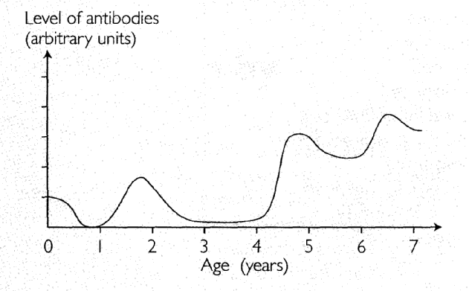
(Spenceley, Weller, Mason, Fullerton, Tsilemanis, Evans, et al., 2004)

(a) The child has antibodies against measles at birth. Explain why.
[x marks]

(b) Explain why the antibody levels drop to zero in the months following birth.
[x marks]

(c) The child was immunised against measles at 1-year old and again at 4-years old.

(i) Explain why antibody production occurs more rapidly and to a higher level after the second vaccination compared with the first vaccination.
[x marks]

(ii) Explain why the antibody levels DON’T drop to zero after immunisation occurs.
[x marks]

(d) At 6 years of age antibody production increases dramatically once again, but no vaccination has occurred. Explain why.
[x marks]

Question 2

Figure 18: Production of polypeptide - model 1

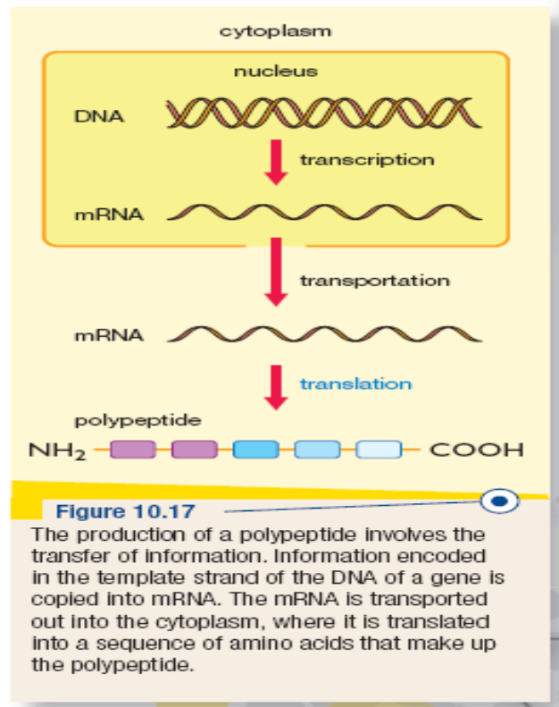
(Evans, Ladiges, & McKenzie, 2005)

Figure 19: Production of polypeptide - model 2

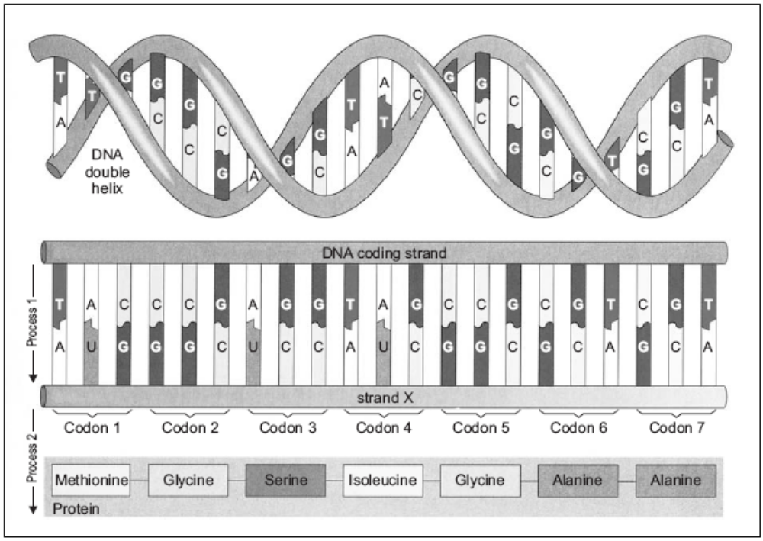
(Queensland Studies Authority, 2003)
(a) Strand X in model 2 is messenger RNA (mRNA). The synthesis of mRNA is controlled by the enzyme RNA polymerase. Explain how the RNA polymerase recognises where to bind to DNA to start the transcription of a particular gene?
[x marks]

(c) Explain the role of tRNA in the translation of the mRNA code into a polypeptide chain. [x marks]

(d) If codon 3 was repeated and codon 4 was removed, what effect might this have on the resulting protein and the body?
[x marks]

(e) All somatic cells in the body have the same genome, but not all genes are expressed in all cells. explain how genes can be regulated to be expressed in specific cells. [x marks]

THIS PAGE HAS BEEN LEFT BLANK INTENTIONALLY
Question 3

Figure 20: Normal knee joint

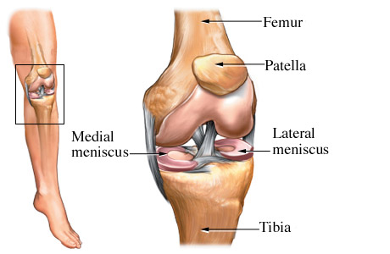
Hyaline Cartilage
Cruciate Ligament
(Nucleus Communications, 2003)

(a) Describe how the gross structure of the knee allows it to flex and extend but restricts rotation. [x marks]

(b) Explain how the tissues forming the following structures are suited to their function in the joint.

(i) tibia. [x marks]

(ii) cruciate ligament. [x marks]

(c) Osteoarthritis is the most common joint disorder and affects most people to some degree by the age of 70 years. Osteoarthritis can begin with an abnormality of cells in the cartilage that produce collagen, causing the cartilage to crack forming tiny cavities in the bone beneath the cartilage.

Explain two different possible types of medical technologies that can be used to treat osteoarthritis.
[x marks]

Figure 21 shows that pathway of the nerve impulse during the knee jerk reflex.

Figure 21: Portion of the nervous system not drawn to scale.

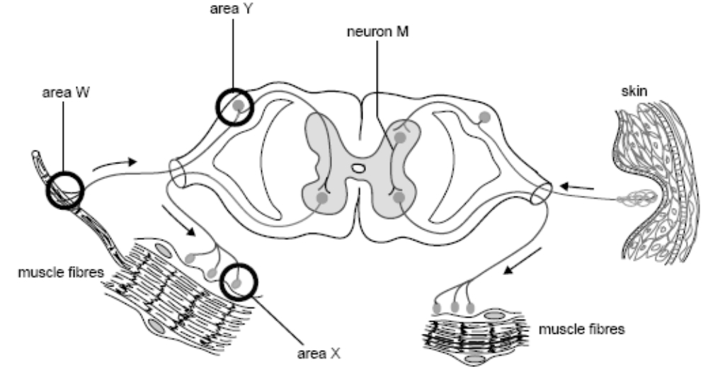
(Victorian Curriculum and Assessment Authority, 2003)

(d) The skin shown in Figure 21 is associated with a reflex arc. Explain how the nerve impulse travels in only one direction in a reflex arc.
[x marks]

(e) When hit with the reflex hammer (1 on the diagram) people react before they know it. Explain why you can’t consciously control a reflex action. [x marks]

(f) Some nerve axons have a myelin sheath. In what way does the myelin sheath affect the function of the cell? How can ageing effects on the myelin sheath affect the functioning of the nervous system?
[x marks]

Question 4
Examine the table below that presents data on blood groups in relation to ethnic groups.

Table 3: Blood groups of different ethnic groups.

Type | Caucasians | African  Americans | Chinese | Eskimos | Australian  Aborigines
O | 45% | 48% | 36% | 46% | 66%
A | 41% | 27% | 28% | 54% | 34%
B | 10% | 21% | 23% | 0% | 0%
AB | 4% | 4% | 13% | 0% | 0%

(a) Given that Australian Aborigines and Eskimos migrated into new areas from populated regions, give an account for the absence of B or AB blood groups in these two ethnic group?
[x marks]

(b) Americans of Caucasian origins have similar percentages of blood groups as shown in the table for Caucasians. Explain why there is a significant difference between the Caucasian Americans and the African Americans blood group percentages even though they have inhabited the same areas for several generations.
[x marks]

3A/3B Section 3 extended answer section.

Answer TWO (2) questions from this section.
Answer EITHER question 1 or question 2.
Answer EITHER question 3 or question 4.
Answer on the lined paper provided at the end of the booklet.

Answer ONE question only from questions 1 and 2.

Question 1

(Board of Studies New South Wales, 2000)

a. The endocrine system of humans functions to control long-term homeostasis in the body, while the nervous system tends to control short-term events. Give TWO reasons for this difference.

b. Name a tissue or organ and the response of it, that is co-ordinated or controlled by BOTH the nervous and the endocrine systems.

c. Using a name condition, outline its effects on the nervous system during ageing.

OR

Question 2

Human blood-calcium concentrations are under homeostatic control. When the concentration of calcium in the blood begins to fall the parathyroid gland releases parathyroid hormone. This hormone stimulates bone cells called osteoclasts to break down bone and release calcium into the blood. When the concentration of calcium rises in the blood specialised cells associated with the thyroid gland release the hormone calcitonin. Calcitonin acts on the bone and increase the amount of calcium that is deposited into the bone.

(a)This information can be presented as a flow chart such as in the figure below. Note that some parts of the chart have been completed.

Use the information given above to complete the flowchart.

Figure 22: Control of blood calcium

blood calcium concentration 2.2 to 2.5 mmolL⁻¹
increase in concentration of blood calcium
decrease in concentration of blood calcium

release release

acts on acts on

causing results in

blood calcium concentration 2.2 to 2.5 mmolL⁻¹
increase in concentration of blood calcium
decrease in concentration of blood calcium

Bone is living tissue. To keep bones strong and healthy, the body is always breaking down old bone and replacing it with new tissue. Different factors control the balance of the breakdown and replacement processes. Osteoporosis is a disease in which bones become fragile and brittle leading to an increased risk and incidence of fractures. The balance is tipped in favour of bone breakdown in osteoporosis.

(b) Low oestrogen levels in females and low testosterone levels in males tend to increase the risk of osteoporosis. Half of all women and one third of men over 60 years in Australia have a fracture due to osteoporosis. Women experience a greater risk of osteoporosis at an earlier age than men.

Explain why this happens.

(c) The risk of osteoporosis is reduced with a high calcium/vitamin D diet and many older women take calcium and vitamin D supplements.
Recent research has found that vitamin A stimulates the action of osteoclasts in bone breakdown. Vitamin A is an important ingredient in creams that promote ‘younger looking skin’ that are used by a great proportion of women over the age of 40 years.

Explain how these actions influence the risk of osteoporosis in older women.

Answer ONE question only from Questions 3 and 4.

Question 3

Recent advancements in human biology and developments in biomedical techniques has allowed genetic researchers to isolate, cut out and transfer individual genes from human cells and transfer them to bacterial cells. The process, called gene splicing, is shown in Figure 23 below.

(a) Explain the events indicated at points A and B to produce the changes shown in Figure 23.

Figure 23: Gene splicing
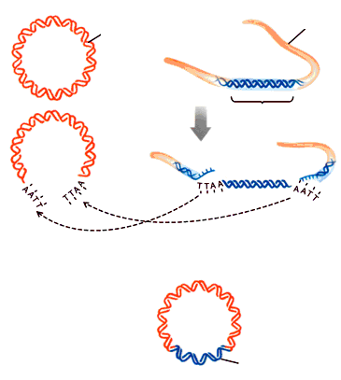
bacterial plasmid
human chromosome
selected gene
selected gene
A
B
(Karp, c1999)

(b) Sickle cell anaemia is a serious inherited blood condition. It leads to kidney and heart failure and without treatment children usually die before the age of 10 years. The condition is caused by a mutation in the gene that codes for beta haemoglobin. There are two alleles for the beta haemoglobin gene: HbA coding for normal beta haemoglobin and HbS coding for the changed haemoglobin. In dividual with two copies of the HbS allele will develop symptoms of sickle cell anaemia.
It is now possible to genetically test people to see if they carry the HbS allele. This test uses PCR, the restriction enzyme MstII and gel electrophoresis.
MstII recognises the 7-base sequence in DNA,

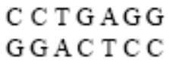

and cuts it between the C and T to produce

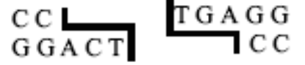

Molecular studies have shown that the sickle allele differs only by one base pair from the normal allele. This base change occurs in the 7-base sequence recognised by MstII. This is the only MstII site found within the region of the gene used in the genetic test.

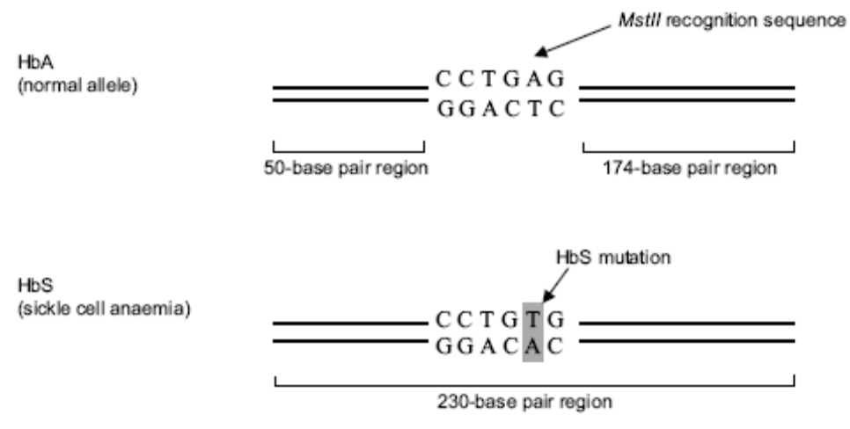
The PCR products are digested using MstII. The resulting fragments undergo gel electrophoresis.

Mark on the following diagram of the gel, the banding pattern you could expect to see for someone who has each of the following genotypes:
i. HbA/HbS
ii. HbS/HbS

Explain the differences in the banding patterns and their use in determining the presence of the sickle cell allele.
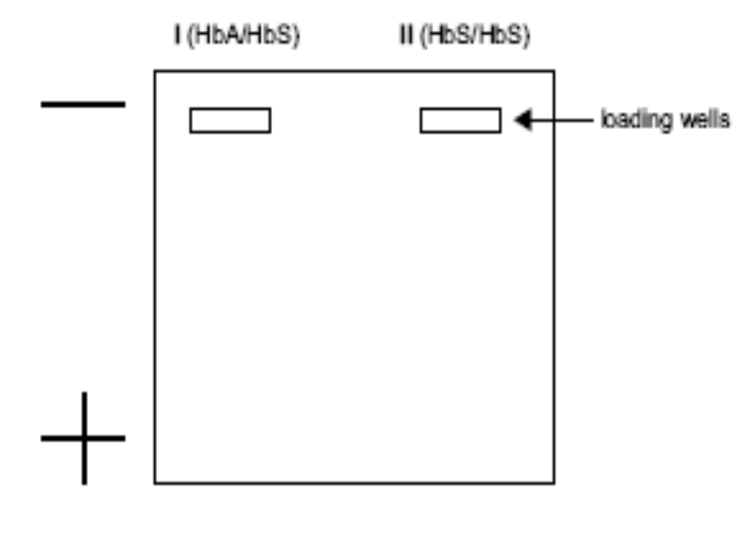
(Victorian Curriculum and Assessment Authority, 2004)

OR
Question 4

(a) Humans are members of Order Primates State the characteristics that humans share with other members of the order and the features that place them into the separate genus Homo.

(b) Figure 24 below show the evolutionary sequence of hominid skulls from the oldest, A. afarensis to the current, H. sapiens.

Figure 24: Hominid skulls

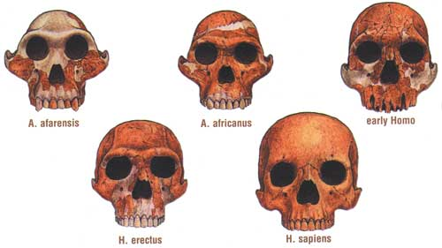
(Hennings, 1999)

Identify three evolutionary changes that are evident when the skull of the modern human is compared with the other skulls below. Suggest ONE reason for each change.

(c) The table below shows the number of nucleotide differences between a region of mitochondrial DNA in humans, chimpanzees and a Neanderthal.
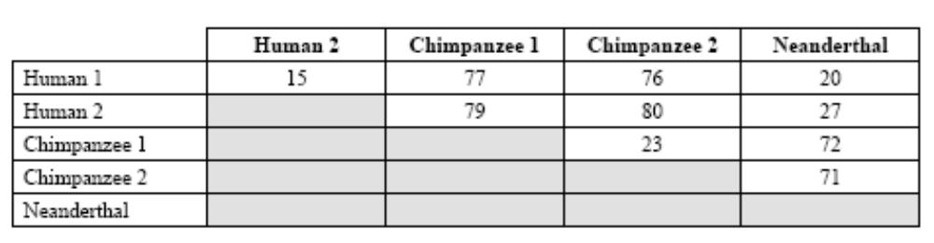
Table 4: Mitochondrial DNA differences in humans, chimpanzees and a Neanderthal.

Based on the data in the table which individual is most closely related to the Neanderthal? Explain your choice.

(Victorian Curriculum and Assessment Authority, 2003)

END OF PAPER

ACKNOWLEDGEMENTS

SECTION 1

Question 3: Victorian Curriculum and Assessment Authority. (2006). Biology: Written examination 1 (p. 8, q. 24). Retrieved November, 2006, from www.vcaa.vic.edu.au/vce/studies/biology/pastexams/2006/2006biol1w.pdf.

Question 4a–c: Adapted from: Tasmanian Qualifications Authority. (2004). Tasmanian Certificate of Education: Biology: Senior Secondary 5C: external assessment (pp. 4–5, q. 5). Retrieved October, 2006, from http://www.tqa.tas.gov.au/4DCGI/_WWW_doc/007022/RND01/BIO5C_paper04.pdf.

Question 4e: Adapted, with the exception of 4e(i) and (ii), from: Victorian Curriculum and Assessment Authority. (2002). Biology: Written examination 2 (pp. 18–19, q. 5). Retrieved November, 2006, from www.vcaa.vic.edu.au/vce/studies/biology/pastexams/biology22002.pdf.

Question 5: Lecher, C.S. (n.d.). Chapter 18 summary, Chapter 18 recommended homework problems. Retrieved October, 2006, from Marian College website: http://sonak.marian.edu/academ/departments/chem_phys/lecher/Ch18.htm.

Question 5c: Adapted from: Victorian Curriculum and Assessment Authority. (2004). Biology: Written examination 2 (p. 16, q. 3). Retrieved November, 2006, from http://www.vcaa.vic.edu.au/vce/studies/biology/pastexams/2004biol2.pdf.

SECTION 2

Question 1: Spenceley, M., Weller, B., Mason, M., Fullerton, K., Tsilemanis, C., Evans, B., et al. (2004). Heinemann Queensland Science Project: Biology: A contextual approach. Melbourne: Heinemann Harcourt Education, p. 454.

Question 2: Evans, B., Ladiges, P., & McKenzie, J. (2005). Heinemann Biology Two (4th ed.). Melbourne: Heinemann Harcourt Education, p. 241.

Queensland Studies Authority. (2003). Biological Science: Paper One: Senior External Examination 2003 (p. 22, q.7). Retrieved November, 2006, from http://www.qsa.qld.edu.au/testing/extern-exams/subjects/biological/2003/03bipr1.pdf.

Question 3: Nucleus Communications. (2003). Normal knee joint [Illustration]. Retrieved October, 2006, from WebMD website: http://www.webmd.com/hw/health_guide_atoz/zm2506.asp.
Copyright © 2006 Nucleus Medical Art, Inc. All rights reserved. www.nucleusinc.com.

Question 3d: Victorian Curriculum and Assessment Authority. (2003). Biology: Written examination 1 (p. 16, fig. 1). Retrieved November, 2006, from http://www.vcaa.vic.edu.au/vce/studies/biology/pastexams/Biology12003.

SECTION 3

Question 1a–b: Adapted from: Board of Studies New South Wales. (2000). 2000 Biology 2 Unit: Higher School Certificate Examination (p. 30, qs 34d(i), (ii)). Retrieved November, 2006, from
www.boardofstudies.nsw.edu.au/hsc_exams/hsc2000exams/hsc00_biology/00biology.pdf.

Question 3a: Karp, G. (c1999). Cell and molecular biology: Concepts and experiments (2nd ed.). Hoboken, NJ: John Wiley, p. 801, fig. 18.33. Retrieved October, 2006, from University of Miami, Department of Biology website: http://fig.cox.miami.edu/~cmallery/150/gene/splicing.jpg.

Question 3b: Adapted from: Victorian Curriculum and Assessment Authority. (2004). Biology: Written examination 2 (p. 23–24, q. 7). Retrieved November, 2006, from http://www.vcaa.vic.edu.au/vce/studies/biology/pastexams/2004biol2.pdf.

Question 4: Hennings, D. (1999). Hominid skulls showing evolutionary transitional forms. Retrieved October, 2006, from Kansas Geological Survey website: http://www.kgs.ku.edu/Publications/Bulletins/ED15/02_history.html.

Question 4c: Adapted from: Victorian Curriculum and Assessment Authority. (2003). Biology: Written examination 2 (p. 20, q. 6a). Retrieved November, 2006, from http://www.vcaa.vic.edu.au/vce/studies/biology/pastexams/2003_biol2.pdf.
Published by the Curriculum Council of Western Australia
27 Walters Drive
OSBORNE PARK WA 6017

